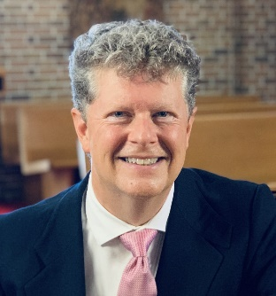A MESSAGE FROM TIM
EASTER is around the corner! I want to thank all those who are currently making memorial gifts to help fund our Easter Day Music! If you’ve not made a gift, I hope you’ll consider doing so! Easter Day is unique in that we have TWO services which are the same service with the same music and musicians at each. If you attend either the 9 or the 11:15 service, you will hear the Choir of St. Gregory’s along with accompanying strings and trumpet singing the Harold Darke mass setting in F and the “Hallelujah Chorus” by Handel, as well as the beautiful anthem by Edward Bairstow, “Sing Ye to the Lord!” Your monetary contributions will help make our first Easter in our renovated sanctuary gloriously beautiful!
This Sunday is St. Patrick’s Day! We will welcome guest musicians Michael O’Gieblyn, violinist, and Aziz Sapaev, cellist, to our 10 am Choral Eucharist as they play a medley of Irish Songs for the Prelude and accompany the choir. Also featured will be a choral mass setting Mass for The Cathedral Church of St. John the Divine which I composed during my tenure as Cathedral Organist at the Cathedral and was debuted at Lincoln Center in 2015 when it was performed in concert by the National Chorale at David Geffen Hall (formerly Avery Fisher Hall.) Michael and Aziz will join me for the communion meditation playing “Celtic Meditation” which I composed a few years ago for our Celtic Eventide service. As we worship on this fifth Sunday of Lent, the choir will sing a beautiful anthem “How Long O Lord” by Eugene Butler which utilizes the text from Psalm 13… How long, O Lord, wilt Thou forget me, how long, O Lord, wilt Thou hide Thy face from me. How long must I bear pain, bear pain in my soul, and bear sorrow all the days of my life. Consider and answer me O Lord, my God. Lighten my eyes, lest I sleep the sleep, the sleep of death. I will sing to the Lord, for I have trusted in Thy Love, in Thy Love, and my heart shall rejoice in Thy salvation.

I’ll see you in church!
Blessings,
Tim

